CHAPTER FOUR
RESULTS, DISCUSSION AND INTERPRETATION OF FINDINGS
4.1: INTRODUCTION

4.2: RESPONSE RATE AND RELIABILITY STATISTICS
Out of the 100 questionnaires administered, 94 were received duly filled. Hence, a response rate of 945has been reached. This is considered as acceptable.
Table 4.1: Reliability Statistics
Cronbach's Alpha | N of Items
0.704 | 13

4.3: FINDINGS
Figure 4.1: Age
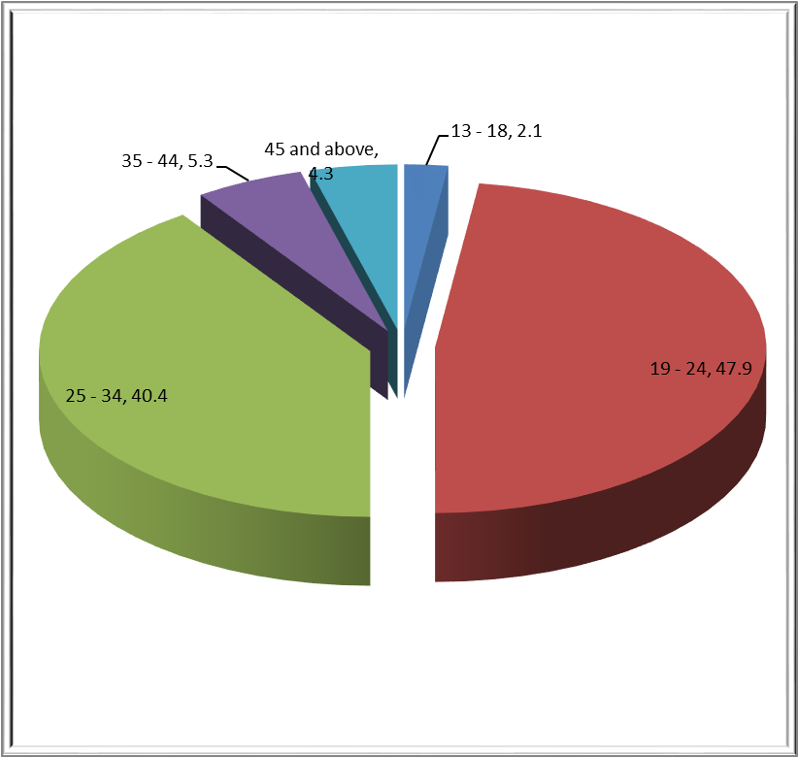

Figure 4.2: Gender
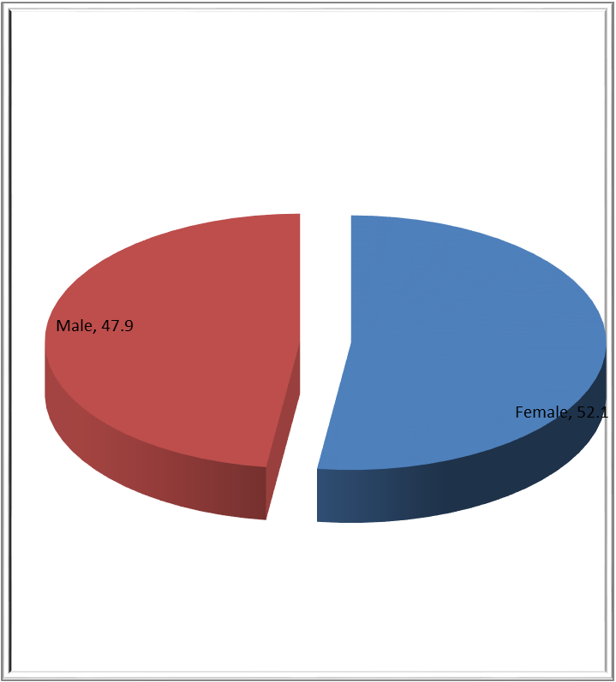

Figure 4.3: Level of education
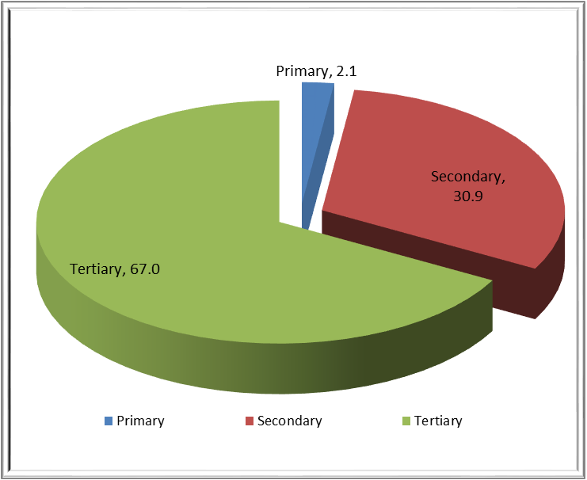

Figure 4.4: Occupation
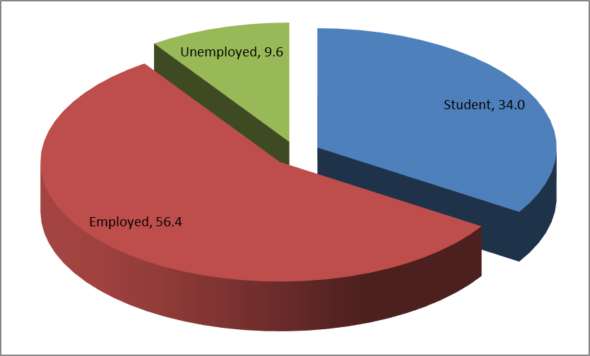

5) To what extent do you think human rights are significant?
Figure 4.5:
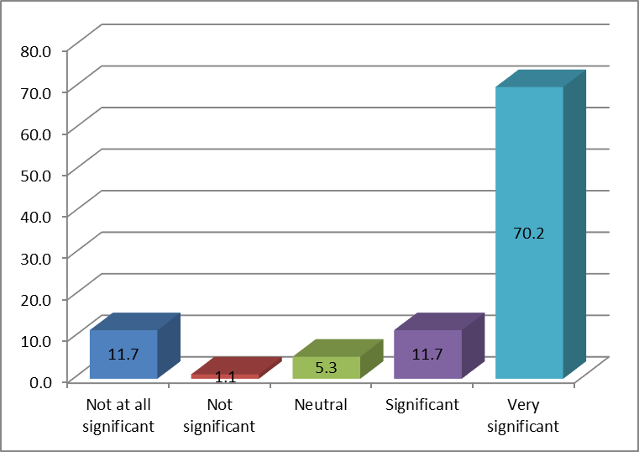

6) How far do you think gender equality is important?
Figure 4.6:

Table 4.2: Correlation with RI 06
 |  | Occupation
RI 06 | Pearson Correlation | -0.26*
RI 06 | Sig. (2-tailed) | 0.01

7) How far do you think women's rights abuses are a main concern in Mauritius?
Figure 4.7:

8) To what extent do you agree that women's empowerment promote political, social and economic development?
Figure 4.8:

9) With reference to the above statement, do you believe that there has been an evolution in women's status from the colonial period up to now? or are they still being discriminated or suppressed?
Figure 4.9:

10) According to your observation, which of the following women's rights violations are most pertinent in Mauritius? (You may choose more than 1 answer)
Figure 4.10:

Table 4.3: Correlation with Menstrual health
 |  | Age
RI 10.10 | Pearson Correlation | 0.22*
RI 10.10 | Sig. (2-tailed) | 0.03

11) Who do you think from the following should be held highly accountable for the infringement of these rights? (You may select more than 1 answer)
Figure 4.11:
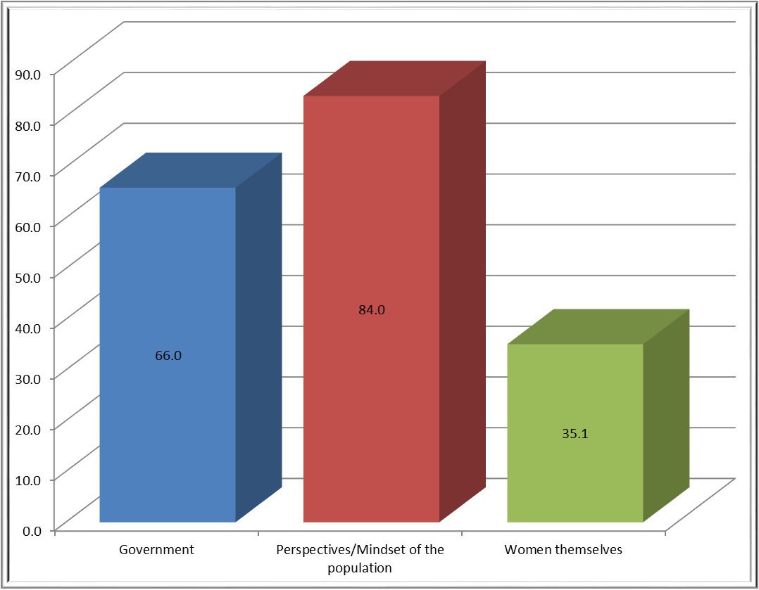

Table 4.4: Correlation with Government
 |  | Gender
RI 11.1 | Pearson Correlation | 0.21*
RI 11.1 | Sig. (2-tailed) | 0.04

12) From your perspective, who are more likely to be subjected to human rights violations? (You may choose more than 1 answer)
Figure 4.12:

Table 4.5: Correlation with Women
 |  | Gender | Level of education | Occupation
RI 12.2 | Pearson Correlation | -0.24* | 0.22* | -0.22*
RI 12.2 | Sig. (2-tailed) | 0.02 | 0.03 | 0.04

13) Who were more likely to experience/face the impacts of the Covid 19? (You may select more than 1 box)
Figure 4.13:

14) Do you think Covid 19 has had adverse impacts on the rights of women?
Figure 4.14:

15) How have women and girls been the most impacted by Covid 19 in Mauritius? (You may choose more than 1 answer)
Figure 4.15:

Table 4.6: Correlation with shouldering the responsibilities of care work - home, workplace, hospitals
 |  | Age
RI 15.4 | Pearson Correlation | 0.23*
RI 15.4 | Sig. (2-tailed) | 0.03

16) Which of the following rights of women have been severely hit by the pandemic in Mauritius? (You may choose more than 1 answer)
Figure 4.16:

17) According to your viewpoint, what could be the barriers jeopardizing women's political rights? (You may choose more than 1 answer)
Figure 4.17:

18) Women experience a number of societal barriers, therefore, according to you, can women and men perform the same duties and shoulder equal responsibilities?
Figure 4.18:
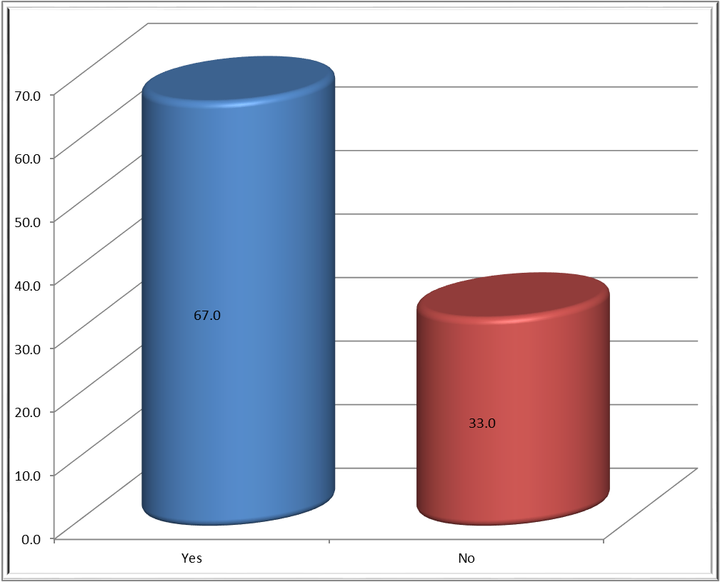

If yes, could you please specify why?
Despite the evolution of the society, women are still subjected to perform certain duties. Women are still expected to go live with their husband and leave their parents behind, look after families, have kids. All questions are directed to women
There's something called equality of opportunities and that should be a major debate
Equality is needed to reduce domestic violence and abuse on women
In every field women have proven how they can be more effective than men thus it proves that women can shoulder most of every responsibility and work given to them.
Yes of course if there will quality in responsibilities equally and support as well specially men should support women
Well sometime there are woman stronger that man so why not?
They are equal and brave
Today we've masons, bus conductors, etc
Different genders have different capabilities
Definitely yes. Nowadays women and men do work shoulder to shoulder. Our education system does cater for equal opportunity to both genders and dare i say both of them are groomed the same.
Men can help in household chores and women might help in construction, taking important decisions how to run the business, financial aspects etc. Women could involve in all type aspects. Both men & women can converse well, good and broad minded and well though play a big role!
There is no difference between man and woman. Everyone is equal. Women can lead in any field.
Women has the ability to handle both, their private and professional life easily.
They have all graduated and have access to nearly everything equally.
Women have the required ability to for shouldering responsibilities and do multitasking.
For example mason, Women and men can both do the same job
The perspective should change because both are human beings and both are entitled to equality therefore we just need to boost their moral support
Both can take on equivalent tasks, be it a challenge intellectually or physically. Both can attain higher level of achievement through adequate training.
Because we are as such strong mentally as them
Women is highly educated than men and many women are working in the engineering or medical field which were considered to be more patriarchal.
They should share responsibilities as equal to one and another
Women have the capacity to endure the triple burden where she could multitask her house duties, family and work but still they are taken for granted compared to the responsibilities expected from men and women are considered weak despite the fact they have the strength to go through menstrual pain and child labor and still there strength is overlook and not to mention that they are better at multi-taskby managing so many thing at a time and still the society as well as the working system pays a men more than a women which is clearly a discrimination and inequality and also within the society, it has been normalizes and as we still live in a patriarchal society and people don't seem to have an issue with this where they are constantly unfair towards women. Women are much more than that and we believe that even man as well as everyone else and that this is just a way to have control over the female population as they may consider it a threat to male ego as well as the society is more scared of equality as men tends to lose their dominance whether be it at home or at work. Equal work pay should be normalized as well as women should be able to acquire any high job position without anyone questioning her capacity or ability to do the job as there are a lot of stereotypes regarding to women having a high job position.
They can do everything like men but if a woman works and have chores to do at home then it may not be possible to reach the same level of men in the political and work area. Achieving high key positions.
Progress can only happen when light is shed on the inequality faced by women. Men accepting to shoulder half of the responsibilities will lead to one less barrier.
Men and women complement but both have the same potentials to excel on the political, professional and any other aspects of life.
Women have proven since a long time that they can do all the jobs that men can do today we have increasing number of women in sports, engineering, wrestling, construction which were previously mainly male dominant
The fact that women have been successful in other jurisdictions put to light that undoubtedly women can perform the same duties and shoulder equal responsibilities.
Women have the capacity to do work as a men
Both can work and bring money just as same both can handle household stuff
No discrimination between them all are equal
Women have the same abilities to handle responsibility. They all have quality education and can equally provide better judgement and capacities to deliver quality jobs.
The social strata says that women cannot perform duty but everyone is human and are capable

If no, could you please specify why?
There are certain work that woman can do better than man and vice versa and it is highly significant in the psychological studies Refer to Jordan Peterson work
Because of their vulnerabilities and weaknesses in doing rational in some situations
Because physiologically men and women are not the same. When we talk about equality and opportunity we talk about cerebral opportunity. Which clearly does not mean we want to be 200 pounds like a man and beat somebody. It is just that if you men have the ability to get the job or be the CEO and nobody questions then why women?
Works that required lots of power & energy could not be done by all women
Can a women be a chief of any religious group? Why? This is one of many reasons!
Men and women are build different by nature. Some tasks require men. And some tasks require women.
Some tasks could be performed by both men and women and some not. For ex. Due to women's physiognomy they can't do heavy tasks like carrying heavy things, materials...
Each gender has their qualities and drawbacks. I would invite all women to try bricklaying if they think they can do everything

19) In accordance to your viewpoint, what could be the barriers hindering women's full participation in the economy in Mauritius? (You may choose more than 1 box)
Figure 4.19:

20) According to you, what could be the constraints hampering Mauritian women's participation in the labor force?
Figure 4.20:

21) According to you, is Mauritius respecting international law and human rights law, despite being signatories to numerous conventions like CEDAW, declaration such as SADC Declaration, protocols, legislations and others?
Figure 4.21:

If yes, why do you say so?
Apparently yes, because the state is answerable if ever there is an offense
These conventions and protocol serves as a guide to elucidate the government about laws and respecting laws is more on an individual basis where people should be educated enough to know their rights and follow that particular trend. Culture is very significant in this context
There's laws n provisions made to protect women.
All efforts done by government
The Mauritian laws do cater for the protection of women rights and implementation of the same is true up to a certain extent. But more needs to be done to ensure fair and just delivery of the law keeping in mind that certain women can easily abuse the same law to inflict irreparable damage to the opposite gender.
No such situations have happened where the rights of women have not been respected and adhered
I don't want to say sorry
Since the colonial era, there have been a lot of improvement in the plight of women but yet more is needed to be done.
We are improving but there's still a long way to go.
Because lots of governmental and non-governmental platforms have been established to help in implementing these conventions such as the Human Rights Commission, Equal Opportunities Commission and a plethora of NGOs run by women to emancipate other women and to help them in their growth. Additionally, there are NGOs which have been established to help women suffering from domestic violence etc.
Yes because women are being able to form part of the political system. However, the amount of women is few and the system has not allowed yet a woman to become Prime minister and thanks to the patriarchal system.

If No, why do you say so?
We still see the equality gap
How the society is, should be a great example
Because women still face violations of their rights.
As we saw recently even policeman are not respecting the rights.
A great example would be the case of police brutality that the population of Mauritius witnessed recently, that is, highly violating the treaty of CAT. The government is also forcing people to do the COVID vaccination and if not done, restricting people to enter some places. Another example would be the freedom of expression that Mauritius is experiencing right now. The country, if i may say, is starting to resemble like a dictatorship instead of a democracy.
The recent for torture videos say a lot about the human rights situation in Mauritius.
Because the treaties impose legal obligations on state so we see that the country is not being able to fulfil those rights
Even though most of the fundamental rights are being respected, there is still discrimination towards certain gender groups.
Human rights are not being respected for example in case of brutality
There are a lot of matters that we feel like we have been breached of our human rights.
Child marriages still existing and using religion instead of human rights.
It is not certain whether all institutions are effectively applying these laws and protocols.
There can still be improvement in the system. Laws can be made more severe
Mauritius has not reached the number of women expected in the general election
Many cases of inequality. Arbitrary arrests. Many incorrect practices hampering human rights.
Most of time such cases of report are issued in police stations

22) Do you think that the laws and other gender-sensitive legislations and civil society regulating gender issues in Mauritius are deterrent and effective enough?
Figure 4.22:

Table 4.7: Correlation with RI 22
 |  | Gender
RI 22 | Pearson Correlation | -0.21*
RI 22 | Sig. (2-tailed) | 0.04

If yes, please specify why?
Women do have many rights in Mauritius and there is a progress in gender related issues
No answer
But still we have some troubled minds
There are many NGOs’ working for the benefits and rights of women
I don't know , I choose randomly
The Constitution of Mauritius guarantees discrimination on the basis of sex and the Equal Opportunities Commission coupled with the Judiciary in Mauritius ensures that there is no discrimination on the basis of sex.
We can see women getting high paid jobs but there are still a huge effort to be done

If no, please specify why?
Women still face inequality
There's nothing that's being done for women and for the LGBTQI+ people despite the numerous laws that exist; the society and laws are still backwards and not modern enough.
The laws could not protect and fulfill their rights
The citizens should be made aware of their rights and how to counter part and voice out their rights violation.
Not enough are being done to sensitise women and young girls in Mauritius
According to me, not enough is done from support authorities for law enforcement in case of repeated aggravations. This can be depicted by the recent cases of assault.
More organisations to empower woman should be there.
There are many things lacking.
Nowadays we encounter an exacerbating cases of domestic violence therefore if the laws was effective enough then maybe instead of exacerbation wiuld be reduction
No
Equality mean fairness irrespective of gender. Not privilege to a certain gender
Because we still live in a male dominated society and there are still a lot of stereotypes related to male and women.
Laws to a large extent cannot change the mindset of people. So despite the existence of laws, people will find more subtle ways to discriminate against or marginalize women in different spheres of life.
Domestic violence and gender discrimination still prevails. And punishments for these crimes are not severe enough
The laws are not specific
Still many cases of domestic violence and discrimination. No appropriate frameworks to tackle the gender based violence issue.
Law is not strict

Figure 4.23:

Table 4.8: Correlation with RI 23
 |  | Age
RI 23 | Pearson Correlation | 0.23*
RI 23 | Sig. (2-tailed) | 0.03

If yes, could you please provide an explanation?
A country is made up of its populace It is much related to cultural aspects and Mauritius being a multicultural country mostly dominated by the east.
With more legislative action, enforcement of new laws and educating youngsters and people about their rights, it could be possible.
Positive steps
Much needs to be done with short, medium and long term implementation planning and a steadfast political will to do so. This will require an implementation master plan which all political parties needs to abide to irrespective of who is in mandate. A plan for all to follow with only minor derivations allowed to cope to changing laws and regulations.
Mauritius has always worked for equality and emancipation of women in the society
Choose randomly , have not read on Iceland gender-equal right
Women have more power of a man
First we do not have enough women's wings and voice and the perspective of the population must change and women should be able to take their own decision and stand for their rights and defend them
Slowly, but social globalisation and increasing gender empowerment/awareness will eventually culminate in such a state.
Women are free to do anything just as men in Mauritius
In terms of securing a job as a woman, we have companies who are promoting woman and are aiming at increasing their amount of woman in the organization.
Yes. It may but it would take time. It also partly depends on the government and the population itself.
Because of the strong legal system prevailing in Mauritius.
I believe that things might change for the better if the future generation think about the development of the country instead of focusing on religious restrictions instead.

If no, could you please provide an explanation?
It will take to change the mentality of people à la base.
The government is not enforcing the laws as it should
Mauritius is still a developing country and people's mind are short, that should make sense
Woman are not empowered and the mindset of the citizens is ailed
We have too many short minded people
No answer
Because of our government itself.
Lack of willingness and resources
Mauritian people have a very different mindset and way of thinking than the people iceland. Iceland can adapt to changes more quickly due to their low population compared to Mauritius.
Here the law is different
We must change the population perception first.
We still live in a patriarchal society so there is a need for improvement for women's rights.
The law still have a lot of improvement to make despite already making effort towards equality. As well not only the government is responsible for those stereotypes but also the mindsets of some part of the society.
The mentality is not the same.
We still have quite a long way to go.
Culture differences play a major role
Unfortunately our population mindset is still yhe main issue. However, with the new generation, the situation might be better er but I believe that there will always be someone who will be against equality as sometimes manly ego gets on the way.
Lots of inequalities
The lifestyles and economies are nor the same and may require a lot of time to reach to that level. There must also be an evolution of mindsets in Mauritius.
Law should be change

24) Through a long journey, Iceland has been able to close approximately 89.2% of their gap, securing the position of a gender-equal country for years, whereas Mauritius having strived hard for gender parity for decades, then how come Mauritius is still lagging behind? What could be the reasons behind? (You may choose more than 1 box)
Figure 4.24:

25) Are you aware of your rights?
Figure 4.25:

If yes, from which sources have you came to know about the rights?
Figure 4.26:

If no, could you please provide us with a small explanation, why you are not aware of your rights?
Apart from the basic human rights [right to freedom, health, speech etc] and a few other non-popular ones, I am not aware of many rights before having to dive into research when I actually need to know them.
I never came across this concept
Never heard
Don’t know

26) Could you please jot down some of your inherited rights that are of utmost significance?
Right to education, express opinion, work
All the human rights
Right to freedom Right to voice out Right to work Right to education
Right to life, right to education, right to Healthcare, freedom of speech and opinion
- The right to life 2. Freedom of expression 3.The right tou equality
My right to express and voice out My right to education which I truly cater for as it could change my life.
Education, life, work, G7
Right to life Freedom of expression Free from torture Right of movement and residence
Section 3 to 18 constitution
Right to education Right to work Right to voice out in case of domestic violence Right to open own business
Disability law and right is still fighting in Mauritius, Mindset toward disable person should change, they should look at us due to respect of our abilities and talent . There is a lot of genius and powerful as a beautiful human beings
Freedom of expression, right to live, right to be independent, right to be treated equally, right to marry
Right to say No
The right to life...the right to freedom of expression...the right to equality....the right to privacy. The right to health. The right to freedom from torture
Right to freedom, health, speech, shelter, equality.
- The right to education
Read the constitution of Mauritius which is the supreme law
Right to life, food, education, religion and freedom of speech
My right to free education My right to travel for free as a student My right to equality My right to basic human rights
Education till the age of 16, that is, SC is very important to me. Being an equal heir to my male siblings. Not being forced for marriage at an early age.
Right to speech, right to live, right to education, right to food
Right to education Right to voice out my opinions Right to freedom and work
Right to education, freedom of speech, no racial, gender,.... discrimination during interview, selection for job interviews should be solely based on capacity of the interviewee and based on the job requirement
Right to life; Right to protection against torture; Right to liberty and protection of the law; Right to freedom of conscience; Right to freedom of association; Right to freedom of movement and of opinion; Right to freedom of expression; Right to freedom of creed and of religious belief as well as the right to private property.
Right to a name, right to education
Freedom of liberty Freedom of speech etc
1. Right to have our own belief 2. Right to work 3. Freedom of speech

27) Have you ever experienced any kind of discrimination, stereotypes or any actions that periled your rights?
Figure 4.27:

If yes, could you please provide an overview of what you have experienced, if you are comfortable to do so?
Toxic relationship
Subjected to stereotypes.
Discrimination at work, where only the ones who are closed or related to the superiors are being promoted
Discrimination in family
I was often taken for granted for the fact of being a girl in term of strength and ability to cope with situations.
At home I study and work at the same time but i still have to commit to much more housework than my male sibling. Especially now with the online classes. Confronting my parents about it i get the silent treatment because they use the fact that one day i will have my own family and i need to do all these. Also if i do a mistake im treated worse than a male just because I’m a girl I’m supposed to be perfect in everything. My appearance also seems to be so important even more than my education and career.
Biased selection for job interview based on face and figure
Due to the pandemic prevailing in Mauritius, I was not allowed to move freely. I understand that the right to freedom of movement is not an absolute right and may be restrained in certain circumstances for instance during a pandemic.

28) Do Mauritian women really know their rights?
Figure 4.28:

Based on your answer (28), why do you think so?
Lack of knowledge, fear of others’ opinion
If they would have been aware of their rights, they would have expressed the violation with hesitation
Lack of awareness
Women seem to have a subordinate role.
Many women nowadays disclose their atrocities and inequalities faced by them most of the times and do not stay silent
Many women pass by what there is actually in laws and forth, they are not aware enough and there's something called strike I think women should actually fight for their rights on the streets and not on social media only, being behind a screen and typing won't change anything
Some women do so, but not all of them
We do not have enough woman's movement and they suffer in silence
Some women proved their will to achieve equality and justice concerning their human rights violation
Women's are educated nowadays
They are brave
Media
Nowadays the media, daily way of life rarely allows for one to invest time and energy on this issue. Also these laws and rights are not easily accessible and not everyone will understand the technical jargon used to express them.
Women have the chance to speak about their rights in social media and in all other informative sources
education make the evolution and changes
Not promoted and talked about.
They don't take things serious, as some just pissed off, they try to come ruin your married life
Because we see that some women are subjected to domestic violence but they prefer silence
Based on the fact that most Mauritians do not know their rights. Main reason being lack of awareness and education from the respective authorities.
Some women doesn't know
Some people are still orthodox.
Nowadays we continue to see women that don’t know their rights...
Most women are educated nowadays
In some communities, women did not opt to continue studies because of poverty and some do not know how to use social media to know about their rights.
Most women despite being independent, we tent to live in a male dominated household and the issue is that there r some families where there are conjugal roles and equality but we can't expect the same from everyone as this is the set of patterns which have shown to be taking place through so many generation and this is where the mindsets have to change as changes starts from home and this is when this when there might actually be a change in the society and also not everyone is aware of their rights due to the people and women not having enough access to these information regarding their rights this is why the government should make these things accessible as this could encourage and make Mauritius a more knowledgeable country.
I see women getting married and not knowing their basic rights example they can keep their own surname without changing it to their husband or adding their husband name to theirs. They are very misinformed about equal property distribution among siblings where each sibling no matter male or female gets equal property or money. Some let themselves manipulated by their siblings or families that they should get less or nothing because they have married into another family. When it is not the case. Also being married they lose a lot during divorce.
Women no longer give in to the enforcement of stereotypes against women or coercion into patriarchal ideologies.
Most of the young women have had free access to education.
Lack of knowledge.
To some extent yes, but not all women
Because some women do not choose to enjoy their rights. It might be because they aren't aware of the same
Some women are not educated enough to know their rights
Many do not try to learn it.
Nowadays woman aware of the rights by media social networking
The young generation is fully aware of it. There are more women working and having responsibility in jobs. More women are able to work at odd hours.

29) Do women stand for their rights and defend them in Mauritius?
Figure 4.29:

If yes, could you substantiate your answer?
Not all of them
More educated population
Media always talk about the rights for women
Women are starting to voice out and take a stand for themselves against injustices against them nowadays.
Yes, but not the majority. While we now have much more women educated in social, legal and political science that can voice out or manifest their rights, there are still a huge percentage of women that still endure their rights being trampled.
Just take a look at how many feminist group are present in Mauritius
We live in the 21st century, everything is changing and women are not scared to voice out their opinions or claim their rights.
Compared to before, most women and girls are more aware of their rights as they are more independent and are not afraid of breaking stereotypes. But the same cannot be said for all as there are some women due to not being educated and not being financially independent are still dependent on their husband and therefore they don't usually have a say in decision taking at home or even sometimes feel suppressed.
I would say the current generation advocate for their rights more than the older generations. The majority of the past generation, despite having more freedom, still believe in their own subjugation.
Partly yes
We often enlightened by the media that women are standing for their rights.
Those who are aware do fight for their rights
Have nog to defend them
Women are not afraid to enjoy themselves and become independent.

If no, could you substantiate your answer?
People who are not educated still lag behind
Many women are not aware of what they are capable in terms of their rights, they often self-jeopardize.
They do not have enough knowledge
Some women are not aware of much of their rights as they accept violation of their human rights and they held silence instead of voicing out or taking actions.
Unaware of their freedom
Not only women but almost all teenagers and young adults do not know it.
a lot of women lack education about their right
If women would know their rights, we would not be living in a man dominating society.
Lack of awareness campaigns
They don't take things serious, as some just pissed off
Men are still viewed as strong individual.
Only talking, no concrete actions...
It all starts with the mentality. If i woman says something she is ignored in the house or called nagging and annoying. In the public and work sphere i heard women voicing out their opinion or reporting something and being transfered or fired out of their jobs.
I believe the fear of hurting their closed ones
Many stay silent during cases of injustice

30) Do you think Mauritius is doing enough in terms of women's empowerment or for the protection of their rights?
Figure 4.30:

If yes, could you please specify why?
I haven't seen any development as such
The introduction of the lespwar app.
There's lots of women emancipation programs and there's also courses n workshops to make women awareness of their rights
Because of gender equality
Always looking for strategies to improve the lives of women
Men are being unfairly treated at the expense of women. Women has the most privileges and the least responsibilities
To some extent yes, women are dominating all working fields as well as excelling in the education fields therefore demanding their rights from the government as well as NGO working for the women's right are active in fighting for the women's right. There are a drastic change compared to before.
We are getting better. There are many organizations that support the empowerment of woman.
As mentioned earlier, there are lots of NGOs helping women to move forward.

If no, could you please specify why?
In school we do not do much to educate children on their rights, The authorities take time to act. Girls living in homes are left on their own, bot really well supported to protect themselves Child pregnancy single mothers are rising
Not enough empowerment or representation through media. No representation of the LGBTQI+ people on the Mauritian platforms also
Increase in cases of domestic violence where women are being dominated, killed and so on.
More could be done
These issues needs to be tackled from a very young age. Since primary school through talks and seminars. Which is not the case.
don't know what to said
Thou they do a lot for woman, there should be more terms for women empowerment.
Lack of communications from responsible parties.
They don't follow their rules
If women were enough empowered we would have seen an increasing rate of women in the political sphere and they would have voice out their sufferings
Even though we have some women in intermediate political roles, it is mainly under direct influence of their male superiors. There should be more awareness whereby 'stereotypical male task and role' are well-maintained by women. Consequently breaking stereotypes and setting the new norm for future generation.
They are but again it starts with the mentality. The media also must be held guilty.
New laws and awareness programs do not represent the only efforts that's needed for women empowerment. This should be analysed based on an individual basis. How is the population accepting of the concept of feminism and to what extent they practice the gender equality that they preach about? Realistically, it's still lacking.
There's not enough campaigns to promote women empowerment and provision of protection against domestic violence which is really common in Mauritius today
Women cater for more than 50% of the population yet only 3 member form part of cabinet of this particular ministry.
More empowerment can be done with available resources and it is a matter of willingness by authorities.
More date should be shared to public
There is still a long way to go because there are some barriers such as religious beliefs and men who still prevent women to become independent. Men fear women with independence.

Correlation Coefficients
0 |  | Age | Gender | Level of education | Occupation
RI 05 | Pearson Correlation | -0.03 | 0.12 | -0.06 | -0.15
RI 05 | Sig. (2-tailed) | 0.77 | 0.25 | 0.57 | 0.14
RI 06 | Pearson Correlation | -0.11 | 0.01 | -0.06 | -0.26*
RI 06 | Sig. (2-tailed) | 0.28 | 0.93 | 0.56 | 0.01
RI 07 | Pearson Correlation | -0.03 | 0.10 | 0.01 | -0.14
RI 07 | Sig. (2-tailed) | 0.76 | 0.34 | 0.91 | 0.18
RI 08 | Pearson Correlation | -0.08 | 0.04 | 0.00 | -0.20
RI 08 | Sig. (2-tailed) | 0.43 | 0.68 | 0.99 | 0.05
RI 09 | Pearson Correlation | 0.02 | -0.38** | -0.04 | -0.03
RI 09 | Sig. (2-tailed) | 0.82 | 0.00 | 0.70 | 0.79
RI 10.1 | Pearson Correlation | -0.07 | 0.06 | -0.10 | 0.14
RI 10.1 | Sig. (2-tailed) | 0.50 | 0.59 | 0.35 | 0.19
RI 10.4 | Pearson Correlation | 0.06 | 0.14 | -0.07 | 0.29**
RI 10.4 | Sig. (2-tailed) | 0.56 | 0.17 | 0.51 | 0.00
RI 10.6 | Pearson Correlation | -0.01 | 0.00 | -0.20 | 0.08
RI 10.6 | Sig. (2-tailed) | 0.90 | 0.99 | 0.06 | 0.43
RI 10.8 | Pearson Correlation | 0.05 | 0.10 | -0.18 | -0.05
RI 10.8 | Sig. (2-tailed) | 0.62 | 0.33 | 0.08 | 0.62
RI 10.10 | Pearson Correlation | 0.22* | 0.06 | -0.17 | 0.31**
RI 10.10 | Sig. (2-tailed) | 0.03 | 0.59 | 0.11 | 0.00
RI 11.1 | Pearson Correlation | -0.11 | 0.21* | -0.16 | 0.07
RI 11.1 | Sig. (2-tailed) | 0.31 | 0.04 | 0.12 | 0.52
RI 11.2 | Pearson Correlation | -0.15 | -0.13 | -0.04 | 0.03
RI 11.2 | Sig. (2-tailed) | 0.14 | 0.22 | 0.69 | 0.76

 |  | Age | Gender | Level of education | Occupation
RI 12.2 | Pearson Correlation | -0.12 | -0.24* | 0.22* | -0.22*
RI 12.2 | Sig. (2-tailed) | 0.24 | 0.02 | 0.03 | 0.04
RI 12.3 | Pearson Correlation | 0.29** | 0.14 | -0.04 | 0.00
RI 12.3 | Sig. (2-tailed) | 0.00 | 0.17 | 0.73 | 0.97
RI 13.2 | Pearson Correlation | -0.08 | -0.07 | -0.05 | -0.03
RI 13.2 | Sig. (2-tailed) | 0.43 | 0.50 | 0.61 | 0.78
RI 15.4 | Pearson Correlation | 0.23* | 0.32** | -0.11 | 0.10
RI 15.4 | Sig. (2-tailed) | 0.03 | 0.00 | 0.30 | 0.35
RI 16.2 | Pearson Correlation | 0.17 | -0.08 | -0.06 | -0.01
RI 16.2 | Sig. (2-tailed) | 0.09 | 0.45 | 0.59 | 0.92
RI 17.5 | Pearson Correlation | .^{c} | .^{c} | .^{c} | .^{c}
RI 17.5 | Sig. (2-tailed)
RI 17.6 | Pearson Correlation | .^{c} | .^{c} | .^{c} | .^{c}
RI 17.6 | Sig. (2-tailed)
RI 17.8 | Pearson Correlation | .^{c} | .^{c} | .^{c} | .^{c}
RI 17.8 | Sig. (2-tailed)
RI 18 | Pearson Correlation | 0.17 | 0.28** | 0.04 | -0.05
RI 18 | Sig. (2-tailed) | 0.11 | 0.01 | 0.71 | 0.62
RI 19.1 | Pearson Correlation | .^{c} | .^{c} | .^{c} | .^{c}
RI 19.1 | Sig. (2-tailed)
RI 19.2 | Pearson Correlation | .^{c} | .^{c} | .^{c} | .^{c}
RI 19.2 | Sig. (2-tailed)
RI 19.3 | Pearson Correlation | .^{c} | .^{c} | .^{c} | .^{c}
RI 19.3 | Sig. (2-tailed)

 |  | Age | Gender | Level of education | Occupation
RI 20.2 | Pearson Correlation | .^{c} | .^{c} | .^{c} | .^{c}
RI 20.2 | Sig. (2-tailed)
RI 21 | Pearson Correlation | 0.00 | -0.04 | -0.06 | 0.04
RI 21 | Sig. (2-tailed) | 0.97 | 0.70 | 0.57 | 0.68
RI 22 | Pearson Correlation | 0.01 | -0.21* | -0.08 | -0.15
RI 22 | Sig. (2-tailed) | 0.94 | 0.04 | 0.43 | 0.16
RI 23 | Pearson Correlation | 0.23* | 0.32** | -0.11 | 0.10
RI 23 | Sig. (2-tailed) | 0.03 | 0.00 | 0.30 | 0.35
RI 24.4 | Pearson Correlation | .^{c} | .^{c} | .^{c}
RI 24.4 | Sig. (2-tailed)
RI 25 | Pearson Correlation | 0.38** | 0.15 | -0.17
RI 25 | Sig. (2-tailed) | 0.00 | 0.14 | 0.11
RI 25.2 | Pearson Correlation | .^{c} | .^{c} | .^{c}
RI 25.2 | Sig. (2-tailed)
RI 27 | Pearson Correlation | 0.05 | -0.17 | -0.13
RI 27 | Sig. (2-tailed) | 0.64 | 0.09 | 0.21
RI 28 | Pearson Correlation | 0.04 | -0.15 | 0.09
RI 28 | Sig. (2-tailed) | 0.72 | 0.15 | 0.38
RI 29 | Pearson Correlation | 0.17 | -0.08 | -0.06
RI 29 | Sig. (2-tailed) | 0.09 | 0.45 | 0.59
RI 30 | Pearson Correlation | 0.01 | -0.12 | 0.06
RI 30 | Sig. (2-tailed) | 0.89 | 0.25 | 0.54
*. Correlation is significant at the 0.05 level (2-tailed).
**. Correlation is significant at the 0.01 level (2-tailed).
c. Cannot be computed because at least one of the variables is constant.

SURVEY QUESTIONNAIRE
SECTION A: DEMOGRAPHIC PROFILE
Age
13 - 18
19 - 24
25 - 34
35 - 44
45 and above
Gender
Female
Male
3) Level of education.
Primary
Secondary
Tertiary
4) Occupation
Student
Employed
Unemployed
SECTION B: INFORMATION ON HUMAN RIGHTS
5) To what extent do you think human rights are significant?
Not at all significant
Not significant
Neutral
Significant
Very significant
6) How far do you think gender equality is important?
Not at all important
Not important
Neutral
important
Very important
7) How far do you think women's rights abuses are a main concern in Mauritius?
Very unlikely
Unlikely
Neutral
Likely
Very likely
8) To what extent do you agree that women's empowerment promote political, social and economic development?
Strongly disagree
Disagree
Neutral
Agree
Strongly agree
Despite the fact that significant and divergent social roles were played by Mauritian women however, their legal status were subordinated to that of their counterparts during the colonial era. There was the prevalence of discriminatory laws limiting women to the domestic sphere. A second-class status was legally and culturally attributed to women highlighting the strong existence of patriarchal ideology in the Mauritian society, where girls were subjected to early marriage and restricted to their reproductive roles. In fact, they had infringement of women's rights
9) With reference to the above statement, do you believe that there has been an evolution in women's status from the colonial period up to now? or are they still being discriminated or suppressed?
Yes, there has been an evolution and they fully enjoy their rights.
Yes, there has been an evolution in certain fields but they are still subordinated and discriminated.
No, there has been no evolution and women are still being discriminated and suppressed.
10) According to your observation, which of the following women's rights violations are most pertinent in Mauritius? (You may choose more than 1 answer)
Women's low political representation
Unequal access to education
Disability & education
Pay gap
Violence & harassment towards LGBT people
Domestic violence & rape (including marital rape)
Teenage pregnancy
Early child marriage
Abortion
Menstrual health
Human trafficking
Unpaid labor, triple shifts
11) Who do you think from the following should be held highly accountable for the infringement of these rights? (you may select more than 1 answer)
Government
Perspectives/Mindset of the population
Women themselves

12) From your perspective, who are more likely to be subjected to human rights violations? (You may choose more than 1 answer)
Men
Women
LGBT
13) Who were more likely to experience/face the impacts of the Covid 19? (You may select more than 1 box)
Men
Women
LGBT
Children
14) Do you think Covid 19 has had adverse impacts on the rights of women?
Yes
No
If yes, could you please substantiate your answer?
If no, could you please justify why you said so?
15) How have women and girls been the most impacted by Covid 19 in Mauritius? (You may choose more than 1 answer)
Experienced precarious livelihoods
Excluded from quality healthcare
Disruptions to education
Shouldering the responsibilities of care work - home, workplace, hospitals
Poverty
Gender-Based Violence

16) Which of the following rights of women have been severely hit by the pandemic in Mauritius? (You may choose more than 1 answer)
Right to life
Right to freedom from torture, cruel, inhuman or degrading treatment
Right to equality
Right to equal protection of the law
Right to freedom of movement
Right to equal pay
Right to marry with full consent of the spouses
Right to work
Right to health
Right to rest and leisure
Right to equal and quality education
Right to participate in cultural life
SECTION C: BARRIERS IMPEDING THE ENJOYMENT OF WOMEN'S RIGHTS
17) According to your viewpoint, what could be the barriers jeopardizing women's political rights? (You may choose more than 1 answer)
Patriarchy
Socialization
Education
Family
Political parties and masculinity
Making and unmaking of alliances
Dirty campaigning
Lack of resources (financial assets)
The Electoral system

18) Women experience a number of societal barriers, therefore, according to you, can women and men perform the same duties and shoulder equal responsibilities?
Yes
No
If yes, could you please specify why?
If no, could you please specify why?
19) In accordance to your viewpoint, what could be the barriers hindering women's full participation in the economy in Mauritius? (You may choose more than 1 box)
Legal barriers (Restrictions on the permitted working hours of women, restrictions on mobility, required permission of husbands or guardians, legal discrimination in assets and land ownership, hurdles in the establishment of national identities and passing on citizenship to children, lack of protection against gender-based violence)
Structural barriers (Inequalities in educational and training accessibility, women's concentration in informal economy, gender gap in unpaid and care work, overrepresentation in the informal sector and low wage work, enjoyment of few benefits and protections, vulnerable to harassment, disproportionate burden of unpaid labor)
Cultural barriers (Cultural attitudes, gender gaps, marital norms, child marriage, acceptability of women's work outside homes)
20) According to you, what could be the constraints hampering Mauritian women's participation in the labor force?
Parental leave legislation
Social norms, socialized and assigned gender roles
Gender salary gap
Safety and violence
Availability and affordability of childcare (mostly for low-income parents)

SECTION D: ASSESSMENT OF THE EXISTING LAWS
21) According to you, is Mauritius respecting international law and human rights law, despite being signatories to numerous conventions like CEDAW, declaration such as SADC Declaration, protocols, legislations and others?
Yes
No
If yes, why do you say so?
If No, why do you say so?
22) Do you think that the laws and other gender-sensitive legislations and civil society regulating gender issues in Mauritius are deterrent and effective enough?
Yes
No
If yes, please specify why?
If no, please specify why?
23) Do you think Mauritius will be able to secure its position as a gender-equal state as Iceland?
Yes
No
If yes, could you please provide an explanation?
If no, could you please provide an explanation?
24) Through a long journey, Iceland has been able to close approximately 89.2% of their gap, securing the position of a gender-equal country for years, whereas Mauritius having strived hard for gender parity for decades, then how come Mauritius is still lagging behind? What could be the reasons behind? (You may choose more than 1 box)
Mauritius lacks resources.
Inefficient and weak leaders.
Women are not amply empowered.
The mindset of population is ailed.
SECTION E: EXPLORING THE CONTEMPORARY MAURITIUS
25) Are you aware of your rights?
Yes
No
If yes, from which sources have you came to know about the rights?
Media
School
Friends
If no, could you please provide us with a small explanation, why you are not aware of your rights?
26) Could you please jot down some of your inherited rights that are of utmost significance?
27) Have you ever experienced any kind of discrimination, stereotypes or any actions that periled your rights?
Yes
No
If yes, could you please provide an overview of what you have experienced, if you are comfortable to do so?
28) Do Mauritian women really know their rights?
Yes
No
Based on your answer (28), why do you think so?
29) Do women stand for their rights and defend them in Mauritius?
Yes
No
If yes, could you substantiate your answer?
If no, could you substantiate your answer?
30) Do you think Mauritius is doing enough in terms of women's empowerment or for the protection of their rights?
Yes
No
If yes, could you please specify why?
If no, could you please specify why?

KMO and Bartlett's Test
Kaiser-Meyer-Olkin Measure of Sampling Adequacy. |  | 0.69
Bartlett's Test of Sphericity | Approx. Chi-Square | 461.921
Bartlett's Test of Sphericity | df | 78
Bartlett's Test of Sphericity | Sig. | 0.000

The Bartlett test was used to check the validity and adequacy of the questionnaire. The function of this test was to determine whether the assumption of equal variances was valid. For reference purposes, the following values shown in Table 3.4 for Kaiser-Meyer-Olkin (KMO) sampling adequacy (Andale, 2016:1);
Table 3.4: References for KMO Values
0.00 - 0.49 | 0.50 -0.59 | 0.60 - 0.69 | 0.70 -0.79 | 0.80 -0.89 | 0.90 -1.00
Unacceptable | Miserable | Mediocre | Middling | Meritorious | Marvellous
Source: Andale (2016:1)
The results of Bartlett test for the collected data is illustrated in Table 3.5. It was observed that the test was highly significant as p value equals to 0.000 at 5% level of significance. Thus, the suitability of the data for this research was meritorious.
Table 3.5: KMO and Bartlett’s Test
KMO Measure of Sampling Adequacy |  | 0.811
Bartlett’s Test of Sphericity | Approx. Chi-Square | 1640.410
Bartlett’s Test of Sphericity | Df | 528
Bartlett’s Test of Sphericity | Sig. | 0.000

According to Andale (2016:1), the Kaiser-Meyer Olkin (KMO) and Bartlett’s Test measure of sampling adequacy is used to examine the appropriateness of factor analysis. From the above table, it can be observed that the approximate of Chi-square is 1640.410 with 528 degrees of freedom, which is significant at 0.05 confidence level. The KMO statistic of 0.811 is also large (greater than 0.50). Hence, factor analysis is considered as an appropriate technique for further analysis of the data.

3.6 Reliability
Van Es (2012:40) defined reliability as the extent to which a questionnaire, test, observation or any measurement procedure produces the same results on repeated trials. A good measure must not only be reliable, but it has to be also valid. The reliability of the answers is measured by studying the Cronbach’s Alpha (α). The Cronbach’s Alpha ranges from zero to one, with zero indicating complete unreliability and a value of one indicating perfect reliability. In general, according to Van Es (2012:40), alpha values lower than 0.70 are not desirable.

Saunders et al. (2012:395) discussed the four types of reliability below:
- Test-retest reliability – refers to a measure of reliability obtained by administering the same test twice over a period of time to a group of individuals;
- Parallel forms reliability – states a measure of reliability obtained by administering different versions of an assessment tool to the same group of individuals;
- Inter-rater reliability – denotes the measurement of reliability used to assess the degree to which different judges or raters agree in their assessment decisions; and
- Internal consistency reliability – signifies a measure of reliability used to evaluate the degree to which different test items that probe the same construct produce similar results.

The internal consistency reliability was applied in this research, as others were not appropriate. The test was used in the questionnaire to ensure consistency and reliability of the closed-ended questions which where the Likert-style rating scale were designed. The Cronbach’s Alpha was calculated by using the SPSS software, and the result is shown in Table 3.6.
Table 3.6: Reliability Statistic – Cronbach’s Alpha
Cronbach's Alpha | Number of Items
0.888 | 29

As explained earlier, a Cronbach’s Alpha at or above 0.7 is deemed to be satisfactory. From the above table, the result obtained was 0.888 which was considered to be good. It also implied that there was a high degree of correlation between the statements in the questionnaire and the internal consistency and reliability among all the 29 Likert scale questions was correct.
Andale. 2016. Kaiser-Meyer-Olkin (KMO) Test for Sampling Adequacy. http://www.statisticshowto.com/kaiser-meyer-olkin/ Date of access: 22 Apr. 2017.
Saunders, M., Lewis, P. & Thornhill, A. 2012. Research Methods for Business Students. 6th ed., England: Pearson Education Ltd, 108-395
Van Es, R.A.J. 2012. The Relationship between Service Quality and Customer Loyalty, and its Influence on Business Model Design, Business Administrations, track Innovation & Entrepreneurship, 27-40

